ELCS PTF Warrior Wear Sale February 17-26
Orders due in the PTF box in the office by February 26, 2021. Visit the school website www.elchristian.org for more information on ordering/online ordering. Contact Pam Anthony (330)853-0710 with questions.
Name: ______________________________ Phone number: ___________________ Student Name: ______________________
- Shirts/sweatshirts available in YS – A4XL.
- Pants YS-A2XL and shorts YS-A5XL.
- Color choices: (shade may vary by style) Carolina Blue, Grey & Pink (Zip up not available in pink).
- Pants/shorts available in black only.
Current Design:
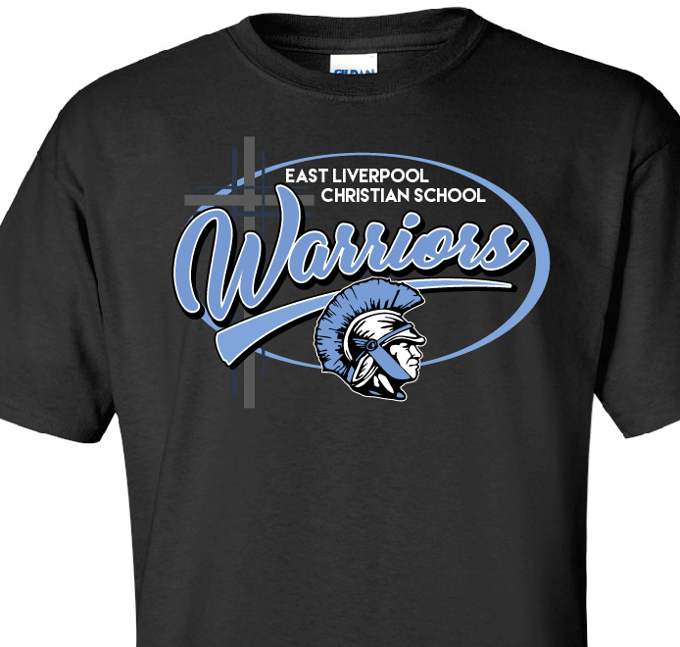

 | Color | Item | YS | YM | YL | YXL | AS | AM | AL | AXL | A2XL | A3XL | Cost each | Total
Total: ________
Please add $1 per X over XL for T-Shirts, sweats and shorts and add $2 per X over XL for all sweatshirts (XL does not cost more). Make checks payable to ELCS PTF; returned checks will be charged $13.50.
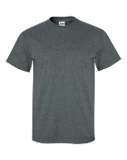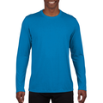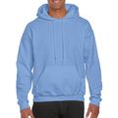
Cotton Tee $15 L/S Cotton Tee $18 S/S Performance $17 L/S Performance $20 Sweatshirt $23 Hoodie $28 runs small
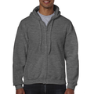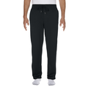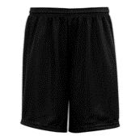
Zip Up Hoodie $34 Sweats $25 Mesh Shorts $18 Car Decal $5 & Yard Sign $10 or bundle both - $13.50

