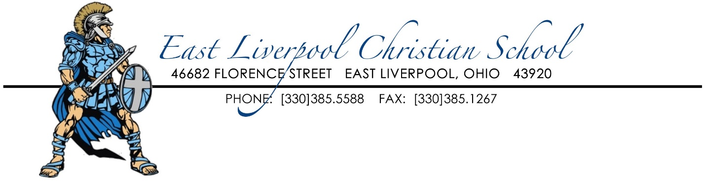

September 21, 2019
Dear ELCS Parents, Grandparents, Guardians,
For over four decades, it has been the mission of East Liverpool Christian School to Provide educational opportunities, founded on Christian principles, to students in our area. ELCS Provides a distinctively Christian Education that equips each student with the knowledge to choose a life of complete obedience of Christ.
We are excited to announce our second annual Provider's Banquet, Thursday, November 7, 2019, at 6:00 PM, at The Heights UB Church. The purpose of the banquet is to raise much needed funding to keep our school in operation, to inform individuals in our area of the mission of our school, and to give them the opportunity to become a financial Provider. Our goal is to increase our ministry to include more interested families, to continue to provide a Christ centered education in East Liverpool, and to raise enough funding to provide our teachers and staff with a respectful wage. However, as non-profit organization we must increase our donor base to accomplish this.
While the banquet itself is free of cost, it is our prayer that each person attending will become part of the Lord's work at ELCS by becoming a Love, Loyalty, or Legacy Provider. Love Provid er give a donation of any amount, Loyalty Provider give a monthly donation of $50.oo or more to the school, and Legacy Providers give a one-time donation of $1,000 or more.
This is an adult only banquet. We are fully aware that our families are already contributing to the success of the school through tuition and service hours. The banquet, however, provides an opportunity for you to reach out to those you know would like to attend the banquet and become a Love, Loyalty, or Legacy Provider, please call Deborah Robinson at the school (330-385-5588) for tickets and reservations. If you are willing to help with this fundraiser, please contact Alice Bowersock (330-368-8292) or Kim Williams (330-831-4628).
Guests at the banquet will also have the opportunity to meet our faculty and staff members. Our Middle School and High School students will be serving tables and hanging up coats. The MC for the event will be Mrs. Peggy Bouscher, School Principal. The speaker for the evening will be business executive Mr. David Bowersock Jr., past student of ELCS having attended 1976 through 1982.
Christian Education creates an environment of respect for God, His Word, and His authority. It lays a foundation of discipline, moral values, and work ethic which impacts our entire society. Please join us in praying for God's blessing to be upon this fundraising event. May the Providers' Banquet unite the Christian community in support of the Christian Education by financially and prayerfully supporting ELCS.

In Christian Love,
Banquet Committee

